Blinking Light Lab
Seth Ricks
ECEN 350
Brother Swenson
11/7/2025

ECEN 350 - Blinking Light Circuit Lab (50 Points)
(jas, ECEN 350 Blinking Light Lab.docx, 11/03/2025)

Purpose: To breadboard and then permanently construct an electronic circuit that visually indicates when it is properly connected. While you can help each other out, each person is to build their own working blinking light circuit. A short lab report is to be created and submitted for credit on this lab. You may keep your completed protoboard circuit.

Parts and Equipment:
- Solderless Breadboard kit with various length hook-up wires for solderless connections.
- Safety glasses.
- Soldering Station including soldering iron, de-soldering tools (pump or solder braid), wire cutter, wire stripper and solder.
1 - Red LED. (See documentation below for proper polarity.)
1 - Green LED. (See documentation below for proper polarity.)
2 - 100 kohm 5% resistors.
2 - 470 ohm 5% resistors.
2 - 10 uF ≥ 25 V Electrolytic Capacitors. (See documentation below for proper polarity.)
2 - 2N3906 transistors. (See documentation below for proper pin connections.)
1 - 9 V Battery Snaps with 4-inch wires.
1 – Protoboard with plated holes for soldering of part.
- Hook-up wire.
- 9V Alkaline battery from Lab Assistant.

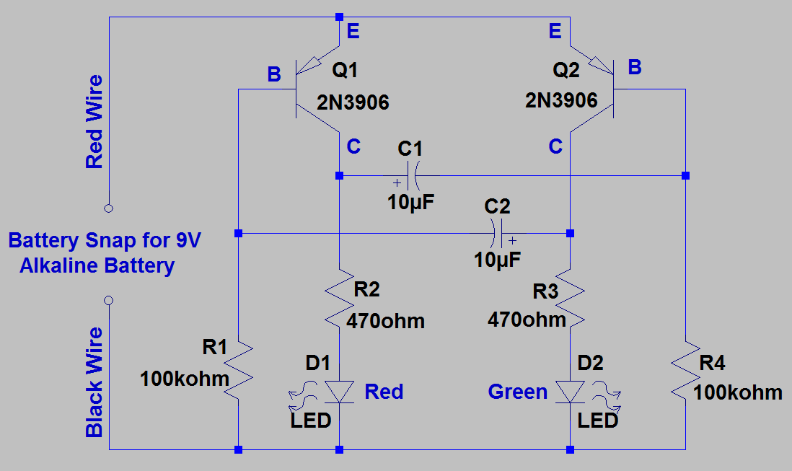
The blinking light circuit in Figure 1 utilizing two pnp bipolar junction transistors (BJTs) is formally referred to as an Astable Multivibrator.

Figure 1. Blinking Light Circuit Schematic.

The circuit in Figure 1 utilizes two pnp transistors to switch on and off the LEDs. Conventional current flows out of the collector of a pnp transistor when it is turned on by the base voltage becoming more negative than the emitter voltage by approximately 0.7 V. Referring to the Figure 1 circuit, transistor Q1 turning on results in an abrupt increase in current flowing through R2 and D1, resulting in D1 emitting visible light. Q1 turning on also results in an abrupt voltage increase on the left-hand plate of capacitor C1. Since you cannot change the voltage across a capacitor instantaneously, the base voltage of Q2 also abruptly increases above 9 V when Q1 turns on, temporarily turned off Q2. Resistor R4 along with capacitor C1 provide a slow decrease in the base voltage of Q2 until eventually Q2 turns on causing diode D2 to emit visible light. Q2 turning on also results in an abrupt voltage increase on the right-hand plate of capacitor C2 causing the base voltage of Q1 to increase above 9 V, temporarily turning off Q1. Resistor R1 along with capacitor C2 provide a slow decrease in the base voltage of Q1 until eventually Q1 turns, and the process repeats.

Procedure:

- Gather the following parts to construct the blinking light circuit shown in Figure 1.

1 - Red LED. (See documentation below for proper polarity.)
1 - Green LED. (See documentation below for proper polarity.)
2 - 100 kohm 5% resistors.
2 - 470 ohm 5% resistors.
2 - 10 uF ≥ 25 V Electrolytic Capacitors. (See documentation below for proper polarity.)
2 - 2N3906 transistors. (See documentation below for proper pin connections.)
1 - 9 V Battery Snaps with 4 inch Red and Black wires.
1 – Protoboard with plated holes for soldering of part.
1 – 9 V Battery from a lab assistant for final testing and photographs.

- Get a solderless breadboard kit with various length hook-up wires for solderless connections.

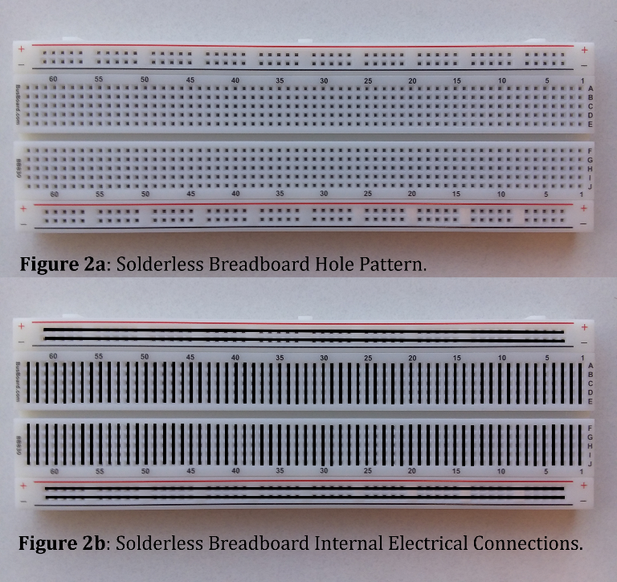
A solderless breadboard is illustrated in Figure 2a, with the rows and columns of holes connected internally as shown in Figure 2b. The two pairs of long rows labeled + and – are intended to provide easy access to power and ground. Hence, connecting the external power supply to one of the long rows labeled + and – provides convenient access to power and ground when several power and ground connections are required.

- Connect the blinking light components on a solderless breadboard as illustrated below in Figure 3. Hookup suggestions, along with component polarity information and pinouts are included in the following documentation.

As can be seen from Figure 1 and Figure 3, there are two symmetrical circuits in the blinking lights circuit, i.e., R1, Q1, C1, R2 and D1, along with R4, Q2, C2, R3 and D2. Utilizing symmetry when placing parts on the breadboard and final protoboard can greatly aid in making the correct connections and in debug if necessary. Figure 3 illustrates a breadboard that uses the symmetry as illustrated in the Blinking Light Circuit schematic.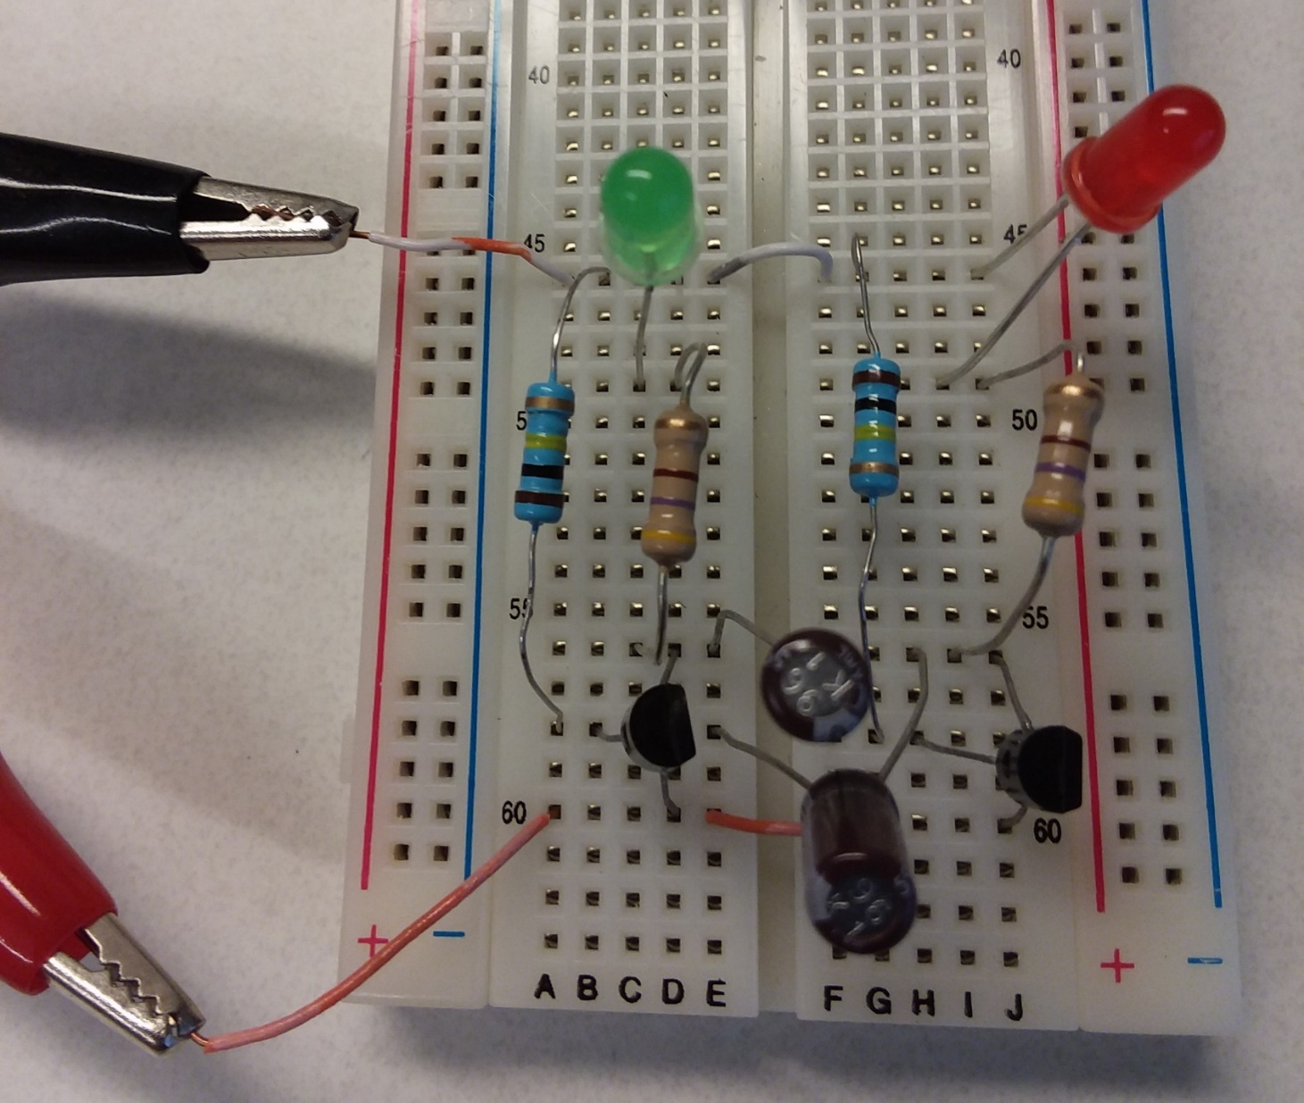
Figure 3. Blinking Light Circuit Breadboard Using Symmetry.

There are four resistors associated with the blinking light circuit, 2 - 100 kΩ resistors (Brown, Black, Yellow) and 2 – 470 Ω resistors (yellow, violet, brown). Make sure that you have the correct resistor values, which can be checked via the color code or a DMM configured to measure resistance.

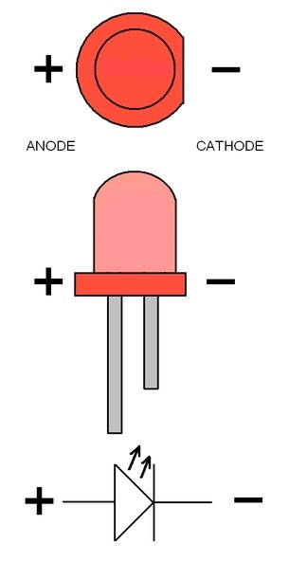
Components C1 and C2 in Figure 1 represent polarized capacitors, meaning that there is a positive and negative lead. Polarized capacitors may explode if the leads are connected to the wrong polarity. On the physical capacitor the shorter of the two leads and/or the lead adjacent to a white polarity stripe on the body of the part indicates the negative lead, which corresponds to the curved plate on the schematic symbol.

Components D1 and D2 in Figure 1 represent LEDs and are also polarized. LEDs won’t explode if installed backwards but prevent proper circuit operation and could be damaged. Figure 4 illustrates a top and side view of a packaged LED, along with the schematic symbol. Like polarized capacitors, the negative lead of an LED is the shorter lead.

Figure 4. Light Emitting Diode (LED).

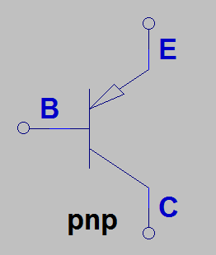
The schematic symbol illustrated in Figure 5 is for a pnp bipolar transistor, with the three terminals referred to as Emitter (E), Base (B) and Collector (C), with the arrowhead denoting the emitter terminal. Transistors are essentially electronically controlled valves for current, with pnp bipolar junction transistors (BJTs) being controlled by the emitter-to-base voltage. If the emitter-to-base voltage is < 0.6 V, then the transistor is operating in cutoff, i.e., and open switch between emitter and collector, and if the emitter-to-base voltage is ≥ 0.7 V then noticeable collector current flows out of the collector terminal.

Figure 5. Schematic Symbol for a pnp Bipolar Junction Transistor.

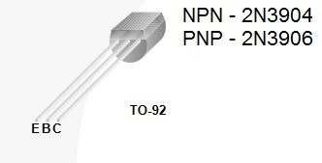
The actual TO-92 package, and associated leads of a bipolar junction transistor is illustrated in Figure 6.

Figure 6. TO-92 Bipolar Junction Transistor Package.

The red (positive) wire from the battery snap connects to the emitters (E) of transistors Q1 and Q2 as shown in Figure 1, while the black (negative) wire from the battery snap connects to resistors R1 and R4, along with the negative terminal of LED’s D1 and D2.

- Get the circuit connected and working properly on a solderless breadboard, prior to soldering the components onto the protoboard with plated holes for soldering. While the battery snap and wires are needed for the final soldered version, those wires utilize stranded wire, which do not work well with breadboards. Consequently, powering your breadboard with the +24V VirtualBench power supply set at 9.0V is recommended for your breadboard. When your breadboard circuit is working properly, transfer the design to the protoboard with plated holes for through-hole soldering, as illustrated in Figures 7 and 8 on the following pages.
- View the following short video on through-hole soldering: How to Solder (3:50). Also, if needed the following video has some advice on removing soldered through-hole components: How to Remove Solder (3:38). (Note: All soldering in STC - 215 is to be done on the wooden solder station boards, to prevent damage to the classroom tables.)

The following are some tips for constructing the circuit on the protoboard with plated holes for soldering:

Tip 1: Unsoldering components from the protoboard is much more difficult than soldering components to the protoboard. So it is recommended that you spend ample time and effort on parts placement and ensuring correct interconnections prior to soldering. Since through-hole solder contains flux in the center of the solder wire, it is not necessary to paint leads with solder flux before soldering.

Tip 2: Leaving ample space between parts, place all the through-hole parts on the same side of the protoboard (topside) with all soldering done on the other side (solder side) of the prototype board. Use the common nodes on the protoboard to provide the necessary electrical interconnections between parts, as illustrated in Figure 8. (Note: The solder side of the protoboard illustrated in Figure 8 has no crossovers and therefore does not require the use of any insulated hook-up wire.)

Tip 2: This circuit utilizes two symmetrical halves, indicating that parts placement can also be done in two symmetrical halves. Also, the capacitors illustrated in Figure 1 are necessary to turn off a transistor, when the opposite transistor turns on. So, constructing the circuit initially without the capacitors C1 and C2, while leaving ample space for the capacitors to be added later, allows one to test and verify that both LEDs are on with 9 V applied. Then adding C1 and C2 to the previously verified circuit should result in the desired blinking LED circuit.

- Where possible test your circuit before soldering and clipping leads to verify proper connections before the final soldering. Since through-hole solder contains flux in the center of the solder wire, it is not necessary to paint leads with solder flux before soldering.
- After the circuit is soldered onto the protoboard and working properly, obtain a 9 V battery for final testing and photographs.
- Take two photographs of the component side of your active Blinking Light Circuit as in Figure 7 below, one showing the red LED on and the other showing the green LED on. Include these photographs, along with Figure numbers and captions, in your lab submission document. If your protoboard circuit is non-functional then take and include one component side photograph of your non-functional device. 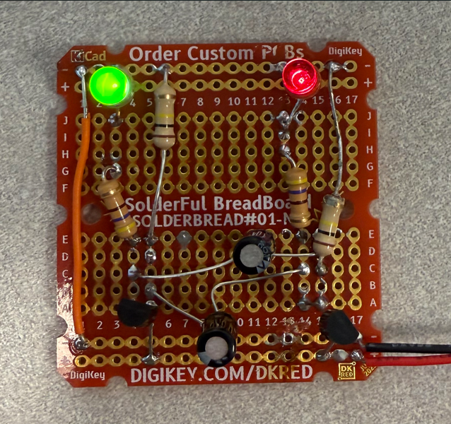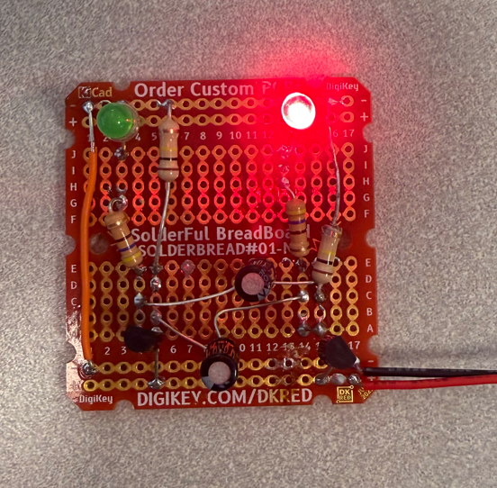
Figure 7. Top Side of a Functioning Blinking Light Circuit Protoboard.

- Photograph the solder side (underside) of your soldered Protoboard as in Figure 8 below. Include this photograph, along with a Figure number and caption, in your lab submission document. 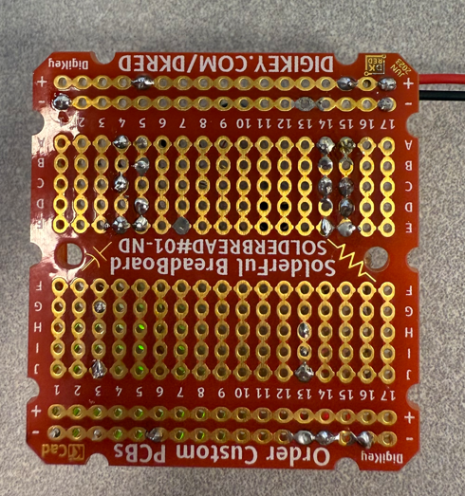
Figure 8. Bottom Side of a Blinking Light Circuit Protoboard.

- Create a new document and complete and submit a lab report that includes the following: Cover Page including class, lab title and author and date, Figure 1 schematic and caption from this document, the two photographs of your working Blinking Light Circuit soldered on a protoboard along with the photograph of the solder side (underside) of your Blinking Light Circuit prototype, including figure numbers and captions. Also include your answers to the following Discussion and Conclusions questions. Then submit a Blinking Light Circuit Lab Report to Canvas with a report Rubric shown below. Again, you may keep your completed circuit, but not the 9 V batteries from the STC.

Discussion and Conclusions Questions: (For the following questions use your own words along with complete sentences. Points are to be deducted for AI generated answers.)

- Describe the functional status of your photographed Blinking Light Circuit as one of the following: Fully functional on the soldered protoboard, partially functional on the soldered protoboard, functional on a breadboard but not when soldered onto a protoboard, breadboarded but not functionsal, or neither breadboard or soldered protoboard completed. (10 Points Possible.)
Fully functional on the breadboard, fully functional on the soldered protoboard.

- Which 4 components illustrated in the Blinking Light Circuit of Figure 1 control the blinking rate of the circuit? (2 points.)
The two capacitors, and the two resistors.

- Describe the main function of pnp transistors Q1 and Q2 in the Blinking Light Circuit of Figure 1. (2 points.)
The transistors act as switches, allowing current flow to alternate between the two LEDs.

- Describe something that you learned from watching the video on through-hole soldering. (2 points.)
One thing that I learned from the video was that if I bend the leads of components when putting them through the holes, it helps them to stay in place easier.

Blinking Light Circuit Lab Grading Rubric:
Lab Report Item | Points
Cover Page | 1
Photograph of the protoboard Blinking Light Circuit with the Red LED on. (12 points, 2 points for figure number and caption. Award 12 points to only 1 of the 2 component side photographs if both LEDs are off, indicating a non-functional circuit, awarding 0 points to the other component side photograph.) | 12
Photograph of the protoboard Blinking Light Circuit with the Green LED on. (12 points, 2 points for figure number and caption. Award 12 points to only 1 of the 2 component side photographs if both LEDs are off, indicating a non-functional circuit, awarding 0 points to the other component side photograph.) | 12
Photograph of the solder side (underside) of the protoboard Blinking Light Circuit. (9 points total. 2 points for figure number and caption.) | 9
Discussion and Conclusions | 16
Total | 50
Please give feedback on errors you find in this document.

